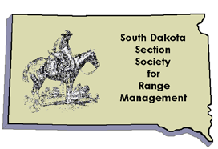

SOUTH DAKOTA SECTION
SOCIETY FOR RANGE MANAGEMENT
SCHOLARSHIP APPLICATION COVER SHEET
Directions: Please complete this form and include with a cover letter and resume’ highlighting your qualifications and financial need. Applications are due by March 15, 2019.
Name_______________________________________
Address:___________________________________ _

Phone:

Email address:

Expected graduation date:

Send Cover sheet, Cover Letter and Resume’ to:
SD-SRM Youth Endowment Committee Chair
Rapid City Regional Center
SDSU Extension
711 North Creek Drive
Rapid City, SD 57003
Or Email to: david.ollila@sdstate.edu

