NOMINATION FORM
"EXCELLENCE IN RANGE MANAGEMENT"
South Dakota Section, Society for Range Management

I. BASIC INFORMATION
Candidates(s) name (s) _________________________________________________________

Mailing Address_____________________________________________County_____________

Is the candidate willing to sponsor a ranch tour in conjunction with SRM?__________________
LAND RESOURCES (ACRES)
Native range Seeded pastures_______________Hayland___________ Cropland Total Land Acres_____________
LIVESTOCK NUMBERS

Cattle: Cows Yearlings Bulls Total
Sheep: Ewes Lambs Rams Total
Horses: Total Other: Total _____

II. Please write a brief reason why this candidate deserves to be awarded the Excellence In Range Management Award:

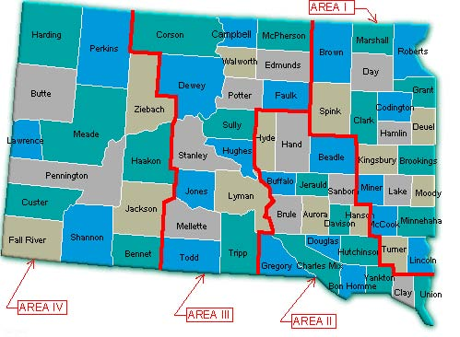

Name, address, and phone number of person
and /or agency sponsoring the nominee:

___________________________________

___________________________________
Area: I, II, III, IV
(circle one)

___________________________________

___________________________________
(Phone No.)

*If your nomination is chosen for further
review, you will be asked to provide more
detailed information with the assistance of
the producer.

Area: I, II, III IV
(Circle one)

